**The Warriors of Ameros**

***ARCHIVES***

*VOLUME V*

***WARNING:* This document uses a custom font that you must install to your font manager in order to see the proper charts at the end of this document. The font file is found in both OTF and TTF format within the “Supporting Images\Etruscan-Phoenician” folder connected where this document resides.**

**This document and font as last updated on 08/08/2020**

Alphabets and Languages

*English*

*Normal Script and News, Verbal*

The primary language in Ameros is English, spoken the same as our equivalent in our world. However, there are differences with the alphabet, as detailed in the chart below:

|  |  |  |  |
| --- | --- | --- | --- |
| **Letter** | | **Name** | **Pronunciation**  **[IPA]** |
| A | a or α | *a* | /ˈeɪ/ |
| B | b | *bee* | /ˈbiː/ |
| C | c | *cee* | /ˈsiː/ |
| Δ | δ | *dee* | /ˈdiː/ |
| E | e or ε | *e* | /ˈiː/ |
| F | f | *ef* | /ˈɛf/ |
| *eff* as a verb |
| G | g | *gee* | /ˈdʒiː/ |
| H | h | *aitch* | /ˈeɪtʃ/ |
| I | i | *i* | /ˈaɪ/ |
| J | j | *jay* | /ˈdʒeɪ/ |
| K | k | *kay* | /ˈkeɪ/ |
| L or Λ | l or λ | *el* | /ˈɛl/ |
| *ell* as a verb |
| M | m | *em* | /ˈɛm/ |
| N | n | *en* | /ˈɛn/ |
| O | o | *o* | /ˈoʊ/ |
| P | p | *pee* | /ˈpiː/ |
| Q | q | *cue* | /ˈkjuː/ |
| R | r | *ar* | /ˈɑːr/ |
| Σ | s, ς | *ess* | /ˈɛs/ |
| *es-* in compounds |
| T | t | *tee* | /ˈtiː/ |
| U or V | u or v | *u* | /ˈjuː/ |
| V or U | v or u | *vee* | /ˈviː/ |
| W | w | *double-u* | /ˈdʌbəl.juː/ |
| X | x | *ex* | /ˈɛks/ |
| Y | y | wye | /ˈwaɪ/ |
| Z | z | zee | /ˈzɛd/ |

There are two extra rules:

* If “Σ” is the final letter in word, and needs to be lower case, it is written as a final “ς” (equivalent to final sigma in Greek).
* “U” and “V” are interchangeable when written, but pronounced based on context. For example, the town name in our English known as “Tauton” can be written in this English as “Tauton” or “Tavton,” both with the same pronunciation on the third letter as /ˈjuː/. Most of the time, these letters are used as is typical in our version of the alphabet and language, but this rule is simply a stylization that needs to be understood.

Below are stroke guides for some of the lower case letters, as they are based on the Greek alphabet:

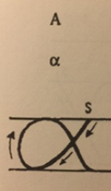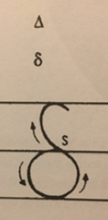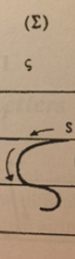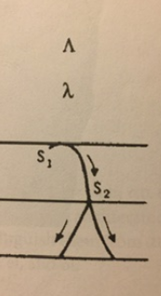*Other Languages within Ameros (Spanish and German)*

*Ancient Engravings and Older Language Forms*

There are only two other prominent languages within the continent of Ameros: what was considered our Spanish and German. Both are not written, or even spoken, as frequently as their version of English. Both are written in the same script/engraving system, with the usage of traditional accents and marking features. The scripts are based on similar sounds written with the letters (based on the Etruscan alphabet, Phoenician style) as follows:

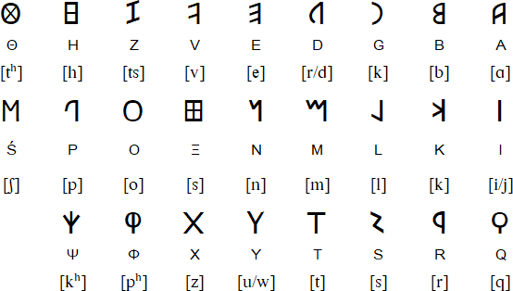

The typical accent markers utilized in Spanish and German will be placed on scripts over (or under) those written letters/engravings. Spaces are denoted by dots directly centered and between each word. Words are written from left-to-right, as is typical. Letters in our modern versions of those languages that have mixed sounds will be replaced by combinations of equivalent letters in the “Etruscan” script.

|  |  |
| --- | --- |
| **Language** | **Marks and Accents used** |
| Spanish | Tilde (ñ), Diaeresis (ü), Acute (é), and the Cedilla (ç) |
| German | Diaeresis (ü) |

Please note that the German eszett (ß) is written in this script simply as a combination of “ś” (long s) and “z” together in the Etruscan alphabet. It is still spoken as a long s with a tailed z, per historic and modern German in our world.

The following chart details the conversions between the latin alphabet and their Etruscan - Phoneician equivalents – with special characters and accent marks – in greater detail:

|  |  |  |
| --- | --- | --- |
| **“Etruscan” Letter** | **Latin or Greek Letter Equivalent(s)** | **Pronunciation(s)**  **[IPA]** |
| A | A | /ˈeɪ/ |
| b | B | /ˈbiː/ |
| d | D | /ˈdiː/ |
| e | E | /ˈiː/ |
| g | G | /ˈdʒiː/ |
| h | H | /ˈeɪtʃ/ |
| i | I | /ˈaɪ/ |
| k | K | /ˈkeɪ/ |
| l | L | /ˈɛl/ |
| m | M | /ˈɛm/ |
| n | N | /ˈɛn/ |
| o | O | /ˈoʊ/ |
| p | P | /ˈpiː/ |
| q | Q | /ˈkjuː/ |
| r | R | /ˈɑːr/ |
| s | S or C | /ˈɛs/ or /ˈsiː/ |
| t | T | /ˈtiː/ |
| v | V | /ˈviː/ |
| x | X | /ˈɛks/ |
| W | F, U, W, or Y | /ˈɛf/, /ˈjuː/, /ˈdʌbəl.juː/, or /ˈwaɪ/ |
| z | Z | /ˈzɛd/ |
| f | Φ | /f/ |
| u | Θ | /θ/ |
| y | Ś | /ʃ/ |

|  |  |
| --- | --- |
| **Adjusted “Etruscan” Symbol or Appropriate Letter Combination** | **Special Character in Spanish and/or German, or a English Letter** |
| 1 | Á |
| 2 | Ä |
| 3 | É |
| 4 | Ë |
| 5 | Í |
| 6 | Ï |
| 7 | Ó |
| 8 | Ö |
| j | Ú |
| J | Ü |
| 9 | Ç |
| 0 | Ñ |
| yz | ß |
| dg; | J |

While not common, the following punctuation marks are used to represent these specific punctuation marks within this engraving pattern in this “Etruscan” script:

|  |  |
| --- | --- |
| **Engraving Mark** | **Punctuation Meaning/Typical Mark** |
| . | “.” - Period/Full Stop/End of a Complete Thought or Clause |
| ? | “?” - Question Mark/Questioning Clause |

Because there are no numbers, numbering is presented in a similar fashion to our Roman Numeral system. The translation and examples are as follows, also showing non-whole number conversions (such as 3.14) using the Question Mark symbol later to determine place value after whole number values:

|  |  |
| --- | --- |
| **Symbol** | **Value** |
| I | 1 |
| W | 5 |
| X | 10 |
| L | 50 |
| G | 100 |
| D | 500 |
| Y | 1000 |

Examples:

* IX = 9 (“One Less than Ten”)
* XI = 11 (“One More than Ten”)
* III?I;?IX = 3.14 (every mark after the first number indicates a respective value below the single digits)